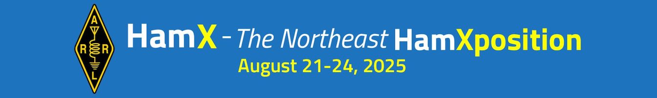

ROBUST LINEUP OF VENDORS AND SPEAKERS AT THE 2025 NORTHEAST HAMXPOSITION

May 29, 2025

For more information, visit: https://hamxposition.org

Plans are shaping up for the 2025 Northeast HamXposition and New England Division Convention on August 21-24, 2025 in Marlborough, Massachusetts.

This year’s convention will be held at the Best Western Royal Plaza Hotel & Trade Center, 181 Boston Post Road W, Marlborough, MA 01752. This venue is located off of I-495 on Route 20 west. It offers many amenities and lots of nearby family-friendly attractions and dining options.

The festivities kick off on Thursday evening, August 22 with entertainment provided by nationally known comedian Juston McKinney. Seating is limited to 250 people. Tickets are just $35, and also available as part of the “Convention Plus” package.

Join your fellow hams for a delicious DXCC/Contest Banquet on Friday night with Ned Sterns, AA7A, as talks about the exciting developments in Remote DXpeditioning and the Radio-In-a-Box (RIB) technology.

Thomas Witherspoon, K4SWL, will present the keynote on Saturday morning. Thomas will discuss how mentorship ensures our amateur radio hobby remains self-sustaining, building lifelong connections that will carry the hobby into the future.

The Saturday evening Grand Banquet will feature special guest Dr. Nathaniel Frissell, W2NAF, on recent HamSCI experiments, what’s next for HamSCI in the future, and how you can participate in these exciting projects.

The Convention will feature dozens of interesting and informative talks, ranging from: Tactical Communications; D-STAR; Antarctic DXpedition; De-mystifying Quantum Computing; Andy’s Linux; New England Wireless & Steam Museum; Large Scale Wi-fi Networks using Amateur Radio Emergency Digital Network; 3-D Printing for the Radio Amateur; A Portable Radio Operator's Pivot to Citizen Science: The Ham Path Less Traveled; and much, much more!

Several new and returning vendors will have their wares on display at the convention this year: FlexRadio, Elecraft, VE2DX Electronics. We’ll also feature Halibut Electronics, Quicksilver Radio, Club Gear Online, Reliance Antennas. Remote Ham Radio, Gold Medal Ideas, AG Custom Gifts, VHQ HEX, and others.

“Mini-Contest University" returns for the second year. Based on K3LR’s popular Contest University, CTU has been featured at the Dayton Hamvention since 2007 and has been presented in 15 countries to over 10,000 participants. Mini CTU is a series of contest-oriented talks and presentations offered at HamXposition all day Friday.

Again this year, volunteers from the Providence Radio Association (W1OP) will staff a special “Get On The Air” station, W1XPO, to mentor and assist newcomers in making their first HF contact.

Our popular EmComm track will be back for 2025. Veteran emergency communicators will share their knowledge and experience to help others to “up their game.” In addition to talks and presentations, convention goers will get to see operational emergency communications vehicles on display in the parking lot.

As always, the Northeast HamXposition will feature a robust flea market, open to tailgaters on Friday, Saturday and Sunday.

No major convention would be worth its salt without great prizes. We're pleased to announce that one lucky person will receive a Yaesu FT-891 mobile transceiver and ATA-120 mobile antenna at the Sunday Closing Ceremonies. The Friday evening DXCC/Contest Banquet raffle will feature an Icom IC-7610 HF/6m Transceiver and DX Engineering Gift Certificates. At the Saturday morning Keynote, we'll be giving away a QMX 5-band QRP transceiver and accessories. And the Saturday evening Grand Banquet, a lucky winner will receive a Yaesu FT-710 HF/6m 100-watt transceiver.

Tickets can be purchased in advance by visiting <https://ticketing.hamxposition.org>.

